

Submitted By:
Umair Umar CE-25-107
Assignment:
CA Lab No. 6
Submitted To:
Mr. Mehmood
For the fulfillment of,
Circuit Analysis Lab
Department of Computer Engineering
University of Engineering and Technology, Lahore

Experiment 6: VERIFICATION OF KIRCHHOFF'S LAWS
Objective
To verify Kirchhoff's current law and Kirchhoff's voltage law for the given Circuit.
Description
KCL: The algebraic sum of the currents meeting at a node is equal to zero.
KVL: In any closed path / mesh, the algebraic sum of all the voltages is zero.
Precautions:
1. Voltage control knob should be kept at minimum position.
2. Current control knob of RPS should be kept at maximum position.

Procedure for KCL:
1. Give the connections as per the circuit diagram.
2. Set a value in RPS.
3. Note down the corresponding readings using multimeter.
4. Repeat the same for different voltages.

Circuit - KCL
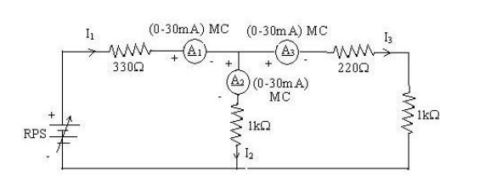
KCL - Practical Values:
Sl. No. | Voltage E (Volts) | I1 (mA) | I2 (mA) | I3 (mA) | I1 = I2 + I3 (mA)
1 | 5 | 5.68 | 3.12 | 2.56 | 5.68
2 | 15 | 17.05 | 9.37 | 7.68 | 17.05
3 | 25 | 28.42 | 15.62 | 12.80 | 28.42

Procedure for KVL:
1. Give the connections as per the circuit diagram.
2. Set a value in RPS.
3. Note all the voltage readings.
4. Repeat the same for different voltages.

Circuit - KVL
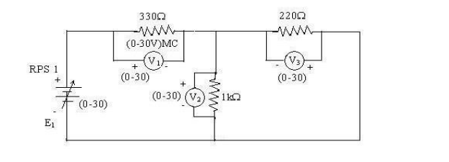
KVL - Practical Values:
Sl. No. | RPS E1 (V) | V1 (V) | V2 (V) | V3 (V) | E1 = V1+V2 (V)
1 | 5 | 3.23 | 1.77 | 1.77 | 5.00
2 | 10 | 6.47 | 3.53 | 3.53 | 10.00
3 | 15 | 9.70 | 5.30 | 5.30 | 15.00

Result:
Thus, Kirchhoff's voltage law and Kirchhoff's current law are verified practically by performing this experiment. The experimental values confirm that the sum of currents at a node equals zero (KCL) and the sum of voltages around a closed loop equals zero (KVL).

Post Lab Questions

1. Define Kirchhoff's Current Law.
Kirchhoff's Current Law (KCL) states that the algebraic sum of all currents entering and leaving a node (junction point) in an electrical circuit is equal to zero. This means the total current flowing into any node must equal the total current flowing out of that node. Mathematically: ΣI = 0 at any node. KCL is based on the principle of conservation of electric charge, which states that charge cannot be created or destroyed at a node. In the experiment, this was verified by confirming that I1 = I2 + I3 at the junction node for all three voltage levels.

2. Define Kirchhoff's Voltage Law.
Kirchhoff's Voltage Law (KVL) states that the algebraic sum of all voltages around any closed loop or mesh in an electrical circuit is equal to zero. This means the sum of all voltage rises (provided by sources) equals the sum of all voltage drops (across resistors) in any closed path. Mathematically: ΣV = 0 around any closed loop. KVL is based on the principle of conservation of energy, which states that the total energy gained by a charge moving around a closed loop must equal the total energy lost. In this experiment, it was verified that E1 = V1 + V2 for all three voltage levels.

3. What are the applications of regulated power supply?
A Regulated Power Supply (RPS) maintains a constant output voltage regardless of changes in input voltage or load current. Its applications include:
i. Used in electronic laboratories to provide a stable and adjustable DC voltage for circuit testing and experimentation.
ii. Used in consumer electronics such as televisions, computers, and mobile chargers to convert and regulate AC mains voltage to required DC levels.
iii. Used in industrial control systems and automation equipment that require stable voltage for sensors, microcontrollers, and actuators.
iv. Used in communication systems such as radios and transceivers where voltage stability is critical for signal accuracy.
v. Used in battery charging circuits to provide controlled charging voltage and prevent overcharging.

4. What are the limitations of KCL?
Although KCL is a fundamental and widely used law in circuit analysis, it has certain limitations:
i. KCL is based on lumped circuit assumptions and assumes that no charge accumulates at a node. This assumption breaks down in distributed parameter circuits where the physical size of the circuit is comparable to the wavelength of the signal.
ii. KCL does not account for displacement currents that arise due to changing electric fields in capacitors at very high frequencies. At microwave and RF frequencies, displacement currents become significant and KCL in its basic form is no longer accurate.
iii. KCL assumes ideal conductors with no leakage current. In real circuits, especially at high voltages, leakage current through insulation can violate the assumption that all current entering a node must leave through conductors.
iv. KCL cannot be directly applied to non-linear or time-varying networks without modification, as these require more advanced formulations.

